1. H1-OLED: OLED 0.96 inch

1. H1-RT: Module thời gian thực RTC DS1307

1. Battery: Mạch Sạc Xả Pin 18650 cổng Type C có đèn báo

1. Buzzer

1. SDCARD: Mạch Ghi Đọc Thẻ Micro SD

1. H1-KEYPAD: KEYPAD 4x4

1. TTL: Mạch chuyển USB UART TTL FT232RL

1. H3-MLX90614: Cảm Biến Nhiệt Hồng Ngoại Không Tiếp Xúc MLX90614

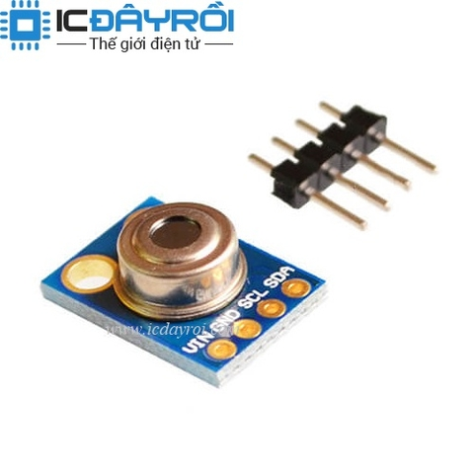

1. H2-YS29: Module phát hiện vật cản YS-29 38KHz 2-180cm

1. H1-FINGERPRINT: Cảm biến nhận dạng vân tay AS608

